***UserDB Database Schema***

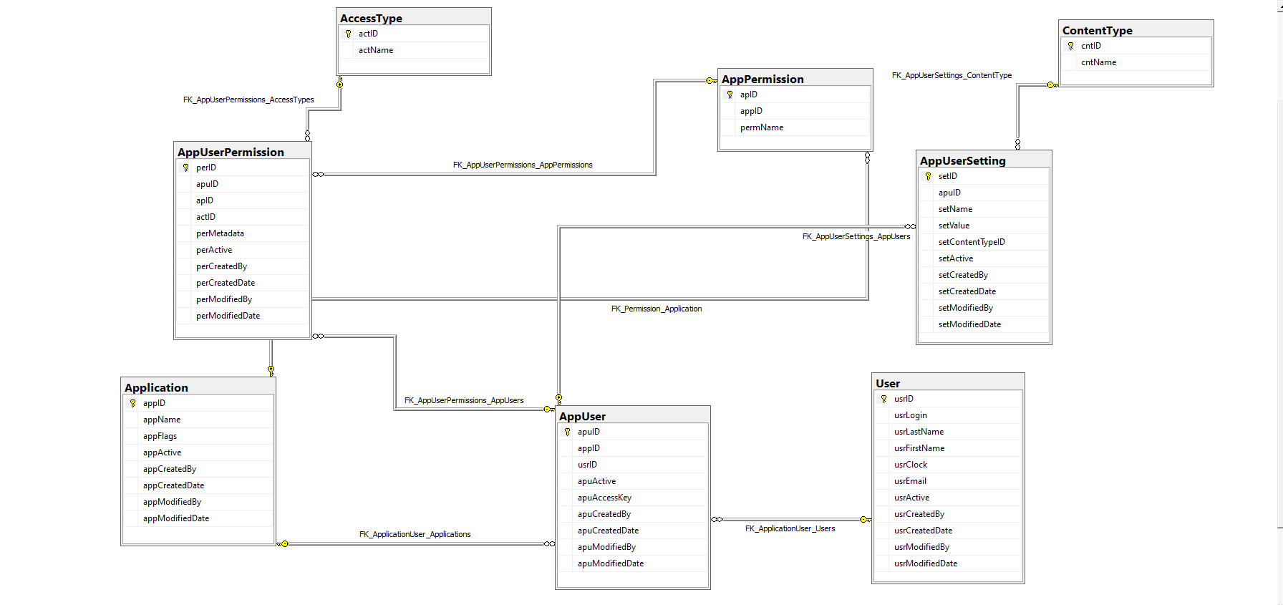

***Foreign Keys***

FK_AppUserSettings_ContentType

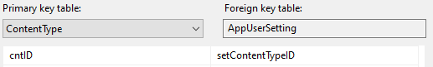

FK_AppUserPermissions_AccessTypes

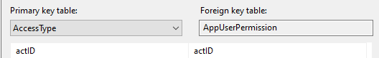

FK_AppUserPermissions_AppPermissions

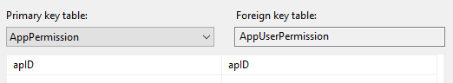

FK_AppUserSettings_AppUsers

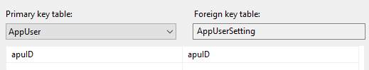

FK_Permission_Application

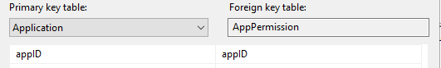

FK_AppUserPermissions_AppUsers

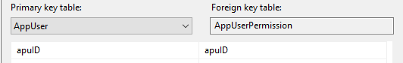

FK_ApplicationUser_Applications

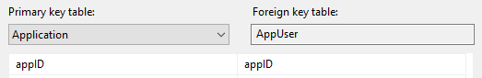

FK_ApplicationUser_Users

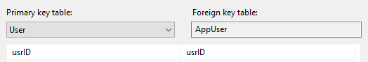

Lookups – FK Reference Tables:

* dbo.ContentType
* dbo.AccessType

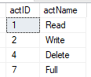

Intersection tables:

* dbo.AppPermission: permission is an attribute of an application.
* dbo.AppUser
  + apuAccessKey column – encrypted user password